Introducing…
“Cyclospora”
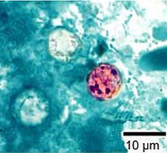
Looks yummy, huh?
…Coming to your state soon, if it’s not there already!
http://abcnews.go.com/GMA/video/stomach-bug-outbreak-tropical-stomach-illness-expands-15-19800768
It’s HERE in Illinois!
Come learn what it is and how to make SURE that your family doesn’t suffer with it!
Let’s be in control of our health and our own FOOD!
When? August 14th at 7:00 pm
Where? My house!
704 Buckskin Drive – Oswego, IL 60543
Feel free to invite and bring others…Everyone deserves to hear and learn! We will be discussing the guarantees of the Juice Plus+ products and what impact they will have for your family’s health.
Just contact me and let me know that you’re coming: Lynne Page 630-988-7441 or
Lynne@LynnesHealth.com

