


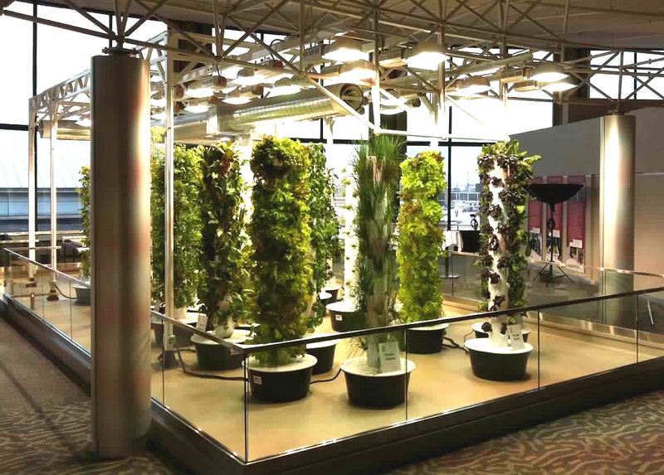
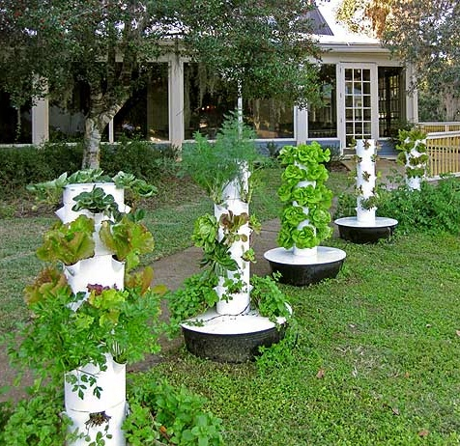
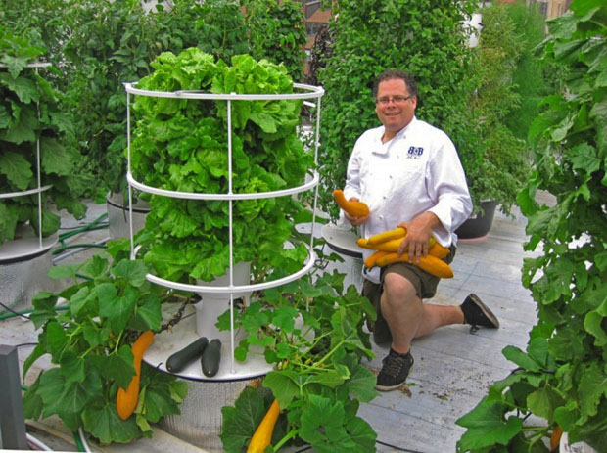
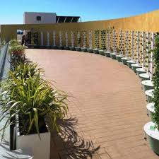
Tower to Table

The Tower Garden System is Popping Up Everywhere
Vertical Gardens are No Longer a Fad

Put a Farmers Market just outside your door. The Tower Garden is a state-or-the-art Aeroponic growing system which is perfect for patios, terraces, rooftop gardens, balconies or just about anywhere there is adequate sunlight. The beauty is that this reusable system requires no soil, no pesticides, no weeding, and only 10% of the water and land required for traditional growing. The Tower Garden was developed by Tim Blank, the former Chief Horticulturalist of the Living with the Land at Epcot Center in Disney World. Bring a friend and come learn about this easy to use system. If I can do it, you can too!!

GARDENParty
GARDENParty
sunday, April 28th
1:00 pm
704 Buckskin Drive - oswego
RSVP text or call:
lynne page 630-988-7441

O’HARE AIRORT CHICAGO
UNITED TERMINAL

U.S. RESIDENTIAL
LANDSCAPE

NEW YORK CITY
RESTAURANT ROOFTOP

L.A. FOOD FARM FOR CHRONICALLY HOMELESS

www.LynnePage.TowerGarden.com

