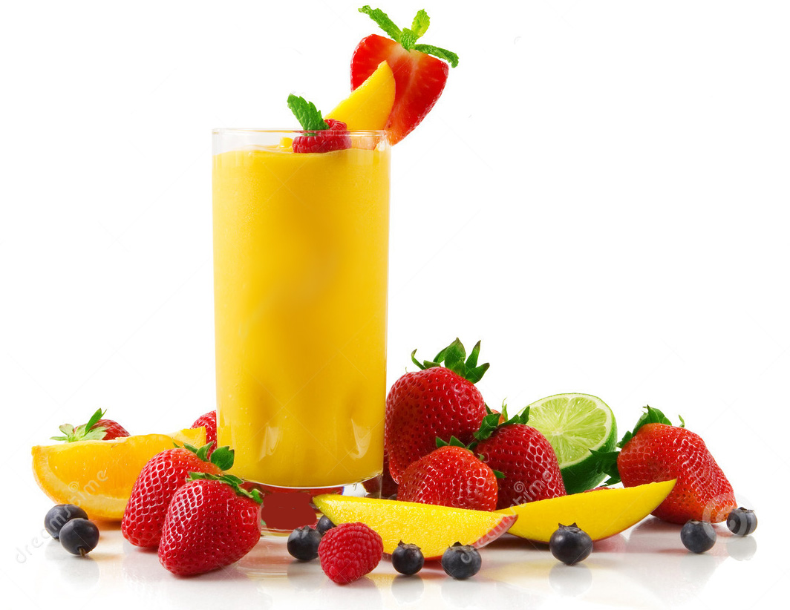


JUMP START TO OPTIMUM HEALTH

Are you ready to achieve your ideal body?
Would you like better sleep, more energy and stamina?
Would you like more vibrant skin & hair?
Would you like more muscle and less body fat?
You can change your body on a cellular level! It’s simple and fun!
Start feeling better and looking better now!

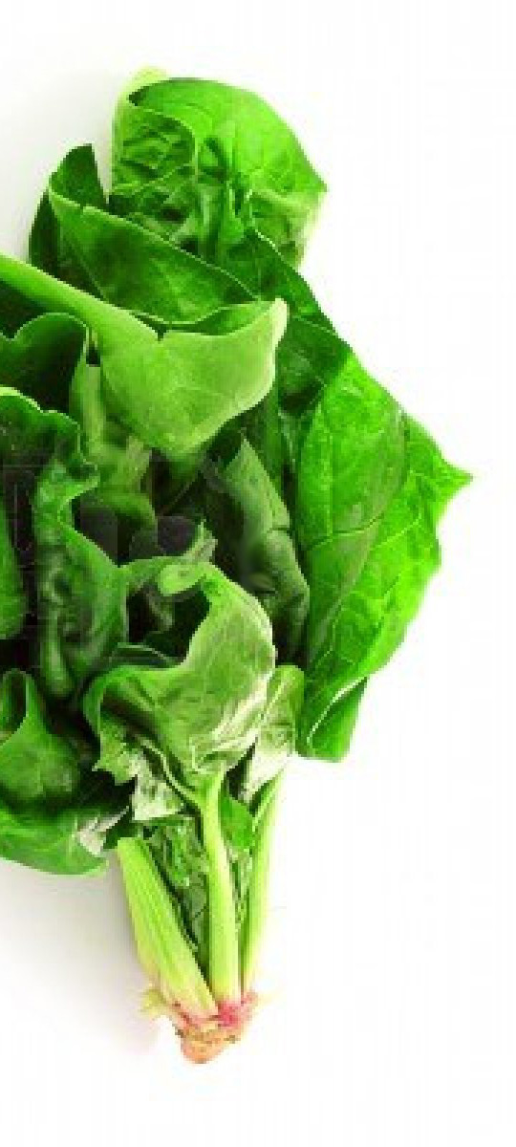
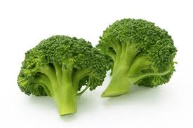
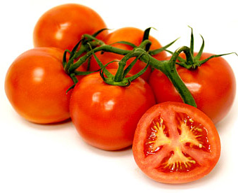
The Juice Plus+ Transformation is about learning how to incorporate simple and effective health habits to help you feel better and look better.
Education and support comes with this lifestyle program.
RSVP by January, 7th to Cathy Campagna at 951-493-6754
or cc@cc4jp.com
You are invited to a Healthy Living Party!
At the home of: Cathy Campagna
in Norco, CA (address provided with RSVP)
RSVPs required! Invite your friends & family!
TWO TIMES TO CHOOSE FROM!!
Thursday, January 9th - 10am to 11:30
or 6:30pm to 8:00
Smoothies and snacks will be served!

YSix Week Program For Vibrant Living

