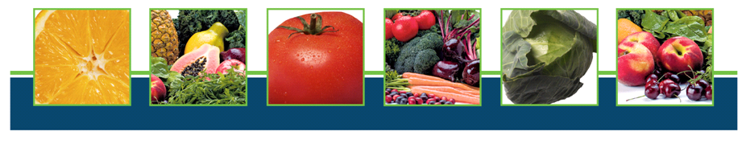
Better Health, Better Life

Featuring Lynne Page, CPY, CYT & NMD

Lynne is a wife and patriotic mother of three great kids, Owner of Lynne’s Health, Inc., Personal Trainer, and a Master Trainer in Aerobics & YOGA Instruction. She took 2nd place in the “East Coast - Miss Fitness USA” contest in 2001, just one year after having her third child. She holds a BS in Exercise Physiology and her Masters in Nutrition. She is certified through the American College of Sports Medicine (ACSM), American Council on Exercise (ACE), Aerobics & Fitness Association of America (AFAA) and American Institute of Fitness Educators (AIFE). She is also a mid-wife, child-birth educator and lactation consultant.

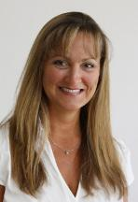

Featuring Cindy Boncosky, RDH

- Why do kids have adult diseases? When we were kids, only old people got them!
- What 4 things can make our kids act ADD or ADHD even if they are normal?
- What do we eat or drink that paralyzes our brains or our kids when they are trying to study?
- Are we giving ourselves osteoporosis?
- Can we REALLY reverse the aging process and get younger? Can we LOOK younger too?
- How old is that "Fresh Produce" anyway?
- Can't I just pop a vitamin pill and be protected?
- What’s the difference between vitamins and whole food?
- Are you holding 5 extra pounds in your middle because your body thinks you are in the desert?

Saturday – March 1, 2014
10:00am Sharp!

Name of establishment
Address, city, st & zip
For more information and to reserve your seat, contact:
Contact name, phone and email address here.
Please RSVP – Space is limited!

This is a free community health education event sponsored by:

Prevention Chicago

