California Drought
Environmental changes from 2011-2014
Lake Oroville – Northern California 80 miles north of Sacramento
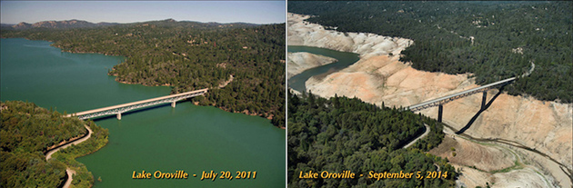
Folsom Lake – 25 miles east of Sacramento
