Grant #
(For grant committee use only)


To complete this form type the appropriate information in the shaded areas, use the tab key or the mouse to move between questions. The shaded area will expand to accommodate the amount of text entered. Save the document and send as an email attachment to oef@owasso.k12.ok.us

Project Title: Towering Greens
Submitted by: Jennifer Farley
School: 7th Grade Center
Daytime phone number: 918-272-1183
Email: Jennifer.farley@owasso.k12.ok.us
Total Amount of Request: $549.00

Project Guidelines:
- Project requests should not be for basic school supplies or equipment that are within the school district’s responsibility to purchase and should directly benefit the student.
- Applicant should demonstrate the need for the grant in the applicant’s school and/or classroom.
- The cost of the project should be in correct proportion to the number of students that will be served. The OEF tends to favor projects that benefit a larger number of students.
- OEF tends to favor project requests that are in some way innovative, creative, and/or technologically progressive.

Grant Review Committee: Grants submitted for consideration are reviewed anonymously by the Grant Allocation Committee. The committee rates each grant based on information submitted and responses provided in the grant application. The Grant Review committee is made up of 10-15 individuals in the community with a passion for Owasso education, some, but not all of the members of the committee have previous education experience, or education experience in other districts.

Rating Criteria: Grant requests will be rated between 1 & 5 in the following six categories, Maximum possible points is 30. The sub-bullets are not individually rated, but provided as a guideline for consideration for the rating of each criterion.

- Need
  - Does it relate to improving student performance or instructional excellence?
  - Does the grant address a critical need?
  - Does the grant emphasis a Common Core Curriculum?
  - Does the grant focus on an area of instruction that receives little to no funding through the school system?
- Encourages Creative Learning in the Classroom
  - Is the grant project innovative?
  - Does the grant proposal go beyond traditional curricular materials?
  - Is the grant project interactive and engaging?
  - Does the grant promote fine arts?
- Effective/Creative Integration of Technology into the Classroom
  - Is the grant specific about how the technology request will be used to improve learning in the classroom?
  - Will the requested technology be used in a way that will engage student learning?
  - Will integration of the requested technology aid student learning in a substantial and measurable way?
  - Is there a clearly articulated relationship between teaching/learning objectives and the requested technology?
  - Are all aspects of the technology request addressed, i.e. ongoing care and maintenance?
- Planning, Organization, Evaluation
  - Is the application concisely written and free from errors?
  - Are objectives clearly stated, and need convincing?
  - Does the proposal clearly explain what is to be done and how?
  - Is the project plan thorough?
  - Are the project goals realistic and clearly stated?
- Number of Students Impacted
  - Class = 1
  - Grade Level = 3
  - School Wide = 5
- Length of Impact of Grant
  - Days = 1
  - Year = 3
  - Multi-Year=5

I have read and understand the above project guidelines and rating criteria, and by submitting this grant application, I understand that any funds not expended for the items listed in the award will revert to the OEF. I further understand that I must provide the OEF with documentation that demonstrates how the funds were employed. Such documentation might include a written summary of the project and the impact on the students, photographs of the students participating in the project, examples of the students’ work, etc. Any publicity about or promotion of the project must include a notation that the project was supported in whole or in part by the OEF.

Grant Application Tips:
Be thorough in explaining the grant request and how it will be used in the classroom. Avoid or explain terms and acronyms that are not familiar to those who do not work within the education system. Attaching a picture of item(s) being requested as a part of the grant can aid in understanding the grant and the rating process. Shop around for the best price, often grant requests are received for the same items with a significant difference in price. If technology items are being requested be sure to address the specific needs/requirement of the item being requested, i.e. memory capacity, newest version versus second generation, etc. It is also important to address how the item will be cared for and protected in order to use over multiple years.
Grant #
(For grant committee use only)

Application should be concise and specific. Please DO NOT mention the name of your school in the text of this application. Application should clearly state the need and objective of the project and the desired outcomes from the project. Application must include the cost of the project and the vendors from whom the supplies will be purchased. Only applications received by the deadline will be considered for approval.

Project Title: Towering Greens
Please check the appropriate box for which the grant is being requested:
Elementary (Pre-K through 5th)
Middle School (6th through 8th)
High School (9th through 12th)

- State the primary objectives of the proposed project.
To study plants at a deeper level and to learn about new technologies that are bettering our environment. To introduce students to the joys of growing your own produce, no matter the weather. To evaluate pH levels, temperatures, and chart our data. To continue to practice measuring using the metric system.

- Describe proposed project in detail.
I would like to purchase a Tower Garden system for our science lab. The Tower Garden stands 5 feet tall and holds 20 plants. It uses state-of-the-art vertical aeroponic growing system. This system recycles nutrients and water, using less than 10% of the water of a traditional garden. NASA research suggests that aeroponic growing takes about half the time of traditional growing. You can grow a variety of fruits, vegetables, flowers and herbs. Chicago’s O’Hare Airport created an urban garden indoors using these towers and the restaurants in the airport are using produce grown just a few feet away. The Tower Garden has been featured on ABC News, The New York Times, and USA Today.
We will go through the seed starter – to seedling – to plant process. With the vertical aeroponic technology, the plants will grow in less time. I feel that this it is important to not only introduce the students to the new innovated systems put in place in this world, but to encourage to try new things and to eat clean. Also, that it is cost effective to provide produce for your family on your own.
We will use this garden to measure temperature, pH levels, and measure the plant growth. We can use this data for production of charts, graphs, draw conclusions and make adjustments based on our findings. It is a science teacher’s dream!
We will not only sample the produce in class, but use this garden to sustain some of the class pets who are veggie eaters. We can share with the teachers and have drawings to take produce home.
There is a valuable YouTube video explaining the Tower Garden. https://www.youtube.com/watch?v=l7EzYmO9u8M

The complete Growing System includes:
- Tower Garden vertical aeroponic garden
- Seeds for growing gourmet lettuce, cherry tomatoes, beefsteak tomatoes, basil, and cucumber
- Seed starter enviro-dome
- 20 rock wool seed starter cubes and net pots
- Pump, timer and drain tube
- Tower Tonic Mineral Blend plant food (1 qt each)
- pH test kit and 1 bottle each of pH+ and pH-
- Measuring cup
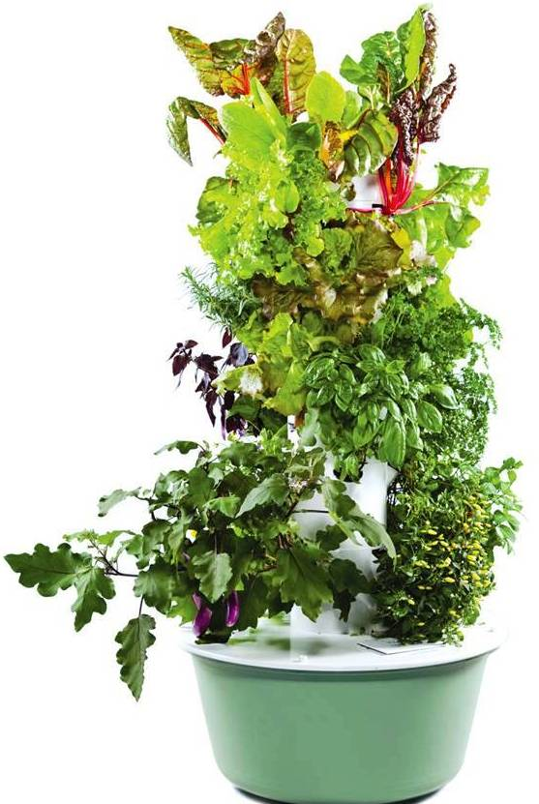

- In what ways might this project be considered innovative?
This project provides avenues to research the new technologies used to create the Tower Garden. It leads us to study plants on a new level and to actually get to reap the benefits first hand of providing nutrition for ourselves and others. At the 7th Grade Center, we lead the district in recycling efforts. This follows the incentive to ‘go Green’ in our school and in America!

- Approximately how many students will be affected by the project at the time of implementation?
150 # affected directly 700+ # affected indirectly
Additional Comments: The Tower Garden can easily be transported to each of our science classes for a series of plant lessons.

- Will students in other classes or schools benefit from this activity/project?
Yes No
If YES, please explain how.
The 7th grade Center leads the district in recycling efforts and our Green Team is the biggest promoter of these efforts. We can use any unused produce or leaves from the Tower Gardens at Green Team meetings to add to the compost bins that we created for each science teacher.

- If funding will support the activity for multiple years, please approximate the number of years and number of students per year.
10+ Approximate # of years 700+ Approximate # affected per year
Additional Comments: The Tower Garden is built to last a lifetime, so it is a smart investment.

- If project can be used multiple years, will additional funding be needed?
Yes No
If yes, for what purpose and how will funding be obtained?
Tower Tonic and the rock wool are the only things required to sustain the garden. It takes so little of it, that our science department can purchase the required amount as needed in years to come. Developed by leading world experts in plant and human nutrition, Tower Tonic Mineral Blend is a mineral solution specifically designed to promote the rapid growth of all types of food and flowering crops. Tower Tonic Mineral Blend provides a pH-balanced blend of natural plant nutrients that stimulate plant roots, flowers, fruits, and leaves.

- In what ways and by what measurable standards will this project be judged a success?
Classroom assessments will be used to measure the growth of student understanding. I would also like the students to create a science process skills video of our transition from seedling to plant. They can make posters stating the steps to the scientific method as they relate to our Tower Garden.

- What is the anticipated implementation schedule?
With standard shipping, we should get started in just a week or so after ordering. There is a wonderful video on YouTube showing a 4 week rapid growth on the Tower Garden. https://www.youtube.com/watch?v=JO-z1Or4RTE

- How will information about the project be shared with OEF, the schools and/or the community?
We would love to share our excitement through submitting photos in the Owasso Reporter, our 7th Grade Center Facebook page and our school and teacher websites! In addition, once our video is created of the progression of the growth process, we will share that as well through our media outlets.

- Detail your budget request below.
Item Description | Supplier | Budget Amount  Including Shipping & Handling
Tower Garden System | Juice Plus+ | $549.00
Sub-Total from attachment
(if necessary)
Grand Total |  | $549.00

(If additional space is needed, itemize and attach in a separate document.)

Completed application should be saved as a Word document and emailed as an attachment to oef@owasso.k12.ok.us. Supporting documentation can be scanned and emailed as attachment along with the grant request.

